**JS SCRIPT FILE EXECUTION IN MONGOSH**

Since mongosh works on Nodejs driver behind the scenes, executing node in REPL mode is available in mongosh, but what if we have to execute the script that is not a one liner in mongosh ? , The answer is writing the script to the .js file and loading in directly in the mongosh to get executed.

* Mongosh Shell is capable of executing only one liners (REPL).
* To execute a multi-line script use .js file execution in mongosh.

**STEPS:**

1. Write down the script to your js file with extension **.mongosh.js** (recommended) as follows:

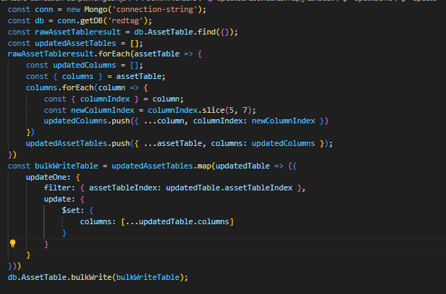

1. Connect to your mongo server using shell.



1. Load your script for execution using **load()**  method of mongosh shell.



1. Hit enter, and the script will be executed!